


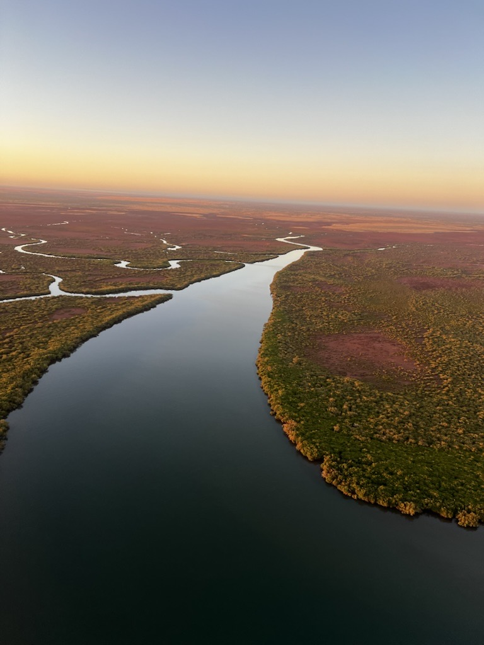
MEETING ITEMS FOR CONSIDERATION
Trust Structure | Updates from Trust Advisory Council & Trustee
Member Benefit Guidelines | Trustee Finance Reports
Announcement of New Trust Advisory Council Members | Q & A Survey

Bus Pick-Up Schedule- Going to the Red Earth Arts Precinct
• Wickham Shopping Centre from 8:00am – 8:15am
• Roebourne 50 Cent Hall 8:45 – 9:00am
• Roebourne Andover Park 9:15 – 9:30
RSVP and Transport Bookings
Please contact the Executive Office via email: assistance@wacrntbc.com.au or phone: 08 8363 7755 to confirm your attendance and reserve a seat on the bus. Please provide the names of all travellers (including children) and your preferred pick-up location.
Trust Advisory Council Nominations
Three Member positions on the Trust Advisory Council need to be elected. Nominations are sought from the Cooper, Boona and Cosmos Family Groups. Please submit nomination forms by email to applications-nt@perpetualwealth.com.au by 30th October 2026. Nomination forms are available on the Wirrawandi Aboriginal Corporation website or from the Executive Office at MLCSassistance@wacrntbc.com.au
IMPORTANT NOTICE: THIS MEETING IS FOR YABURARA AND COASTAL MARDUDHUNERA CHARITABLE TRUST MEMBERS ONLY
NO SITTING FEES WILL BE PAID FOR THIS MEETING

Meeting Date: | Friday, 6 November 2026
Registration: | 10:00am
Meeting Time: | 10:30am – 2:00pm
Location: | Studio Room, Red Earth Arts Precinct, Karratha
Meeting: | Yaburara and Coastal Mardudhunera Aboriginal Charitable Trust Community Meeting

Microsoft Teams meeting Join: https://teams.microsoft.com/meet/49511281157532?p=it46mrjdgkGgZjl15l
Meeting ID: 495 112 811 575 32
Passcode: YE3Ey6Ux

YABURARA AND COASTAL MARDUDHUNERA ABORIGINAL
CHARITABLE TRUST
COMMUNITY MEETING NOTICE

